EXAMINATION
Working with SQL Server Database Objects (SSDO) and RDBMS
Time: 90 minutes
No 1
RDBMS

In SQL Server 2005, write SQL scripts for the following questions:

- Create a database named EmploymentManagement. (5 marks)
- Create 2 tables as the following figure: (10 marks)
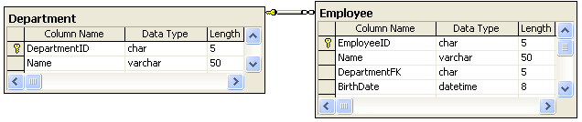
And this database satisfies below constraint:
- Default value for BirthDate is Dec 10th, 1970.

- Input at least some records for each table. (10 marks)

DepartmentID | Name
1 | IT
2 | Human resource
3 | Research
4 | Business

EmployeeID | Name | DepartmentFK | BirthDate
1 | Micheal John | 1 | 21/04/1970
2 | Anna Lombard | 2 | 02/01/1972
3 | Peter Dawson | 3 | 12/07/1990
4 | Leonard | 4 | 25/05/1981
5 | Elizabeth | 3 | 14/03/1970

- Create a select statement to show EmployeeID, Name and Age of all employees that were borned after 1975. (5 marks).
- Create a select statement to show details of employee that are working for “Research” department. (5 marks).
- Create a statement to show total of employees who are working for “Research” department. (5 marks).
- Create a update statement to update the employees who are working in “Business” department to “Research” department. (5 marks).
- Create a delete statement to delete all the employees that are working in “IT” department and year of BirthDate in 1970. (5 marks).

SSDO

- Create a view named ViewEmployees to show all information of employees, such as EmployeeID, Name, BirthDate and DepartmentName (DepartmentName is the name of a department which an employee belongs to). Then, display data of this view with a column DepartmentName is sorted ascending. (20 marks)
- Create a stored procedure named ProcDeleteDepartment with input parameter named @departmentId. This stored procedure deleted a department which DepartmentID is equal to an input value for @departmentId. Then, execute this stored procedure to delete a department which values are ‘3’. (20 marks)
- Create a trigger named TriggerInsertEmp for Employee table to ensure that when user executes an insert statement on this table, age of the inserted employee is more than 30 years old. (10 marks)

Submit PE with .sql file(MSSV_Ten_Lop_Mon) into LMS by the end off time finished.

